666Week03 - Testing Database

SQL to check the tables

EVIDENCE REQUIREMENT

1. A COPY OF THE SQL CODE THAT COMPLETES EACH OF THE REQUESTED QUERIES
2. THE OUTPUT SHOWING THE RESULT FROM RUNNING THE QUERIES – USE SNIPPING TOOL TO SHOW THE OUTPUT

Q1. Check that each table will display the output presented in the individual tables

Select *

From customer;

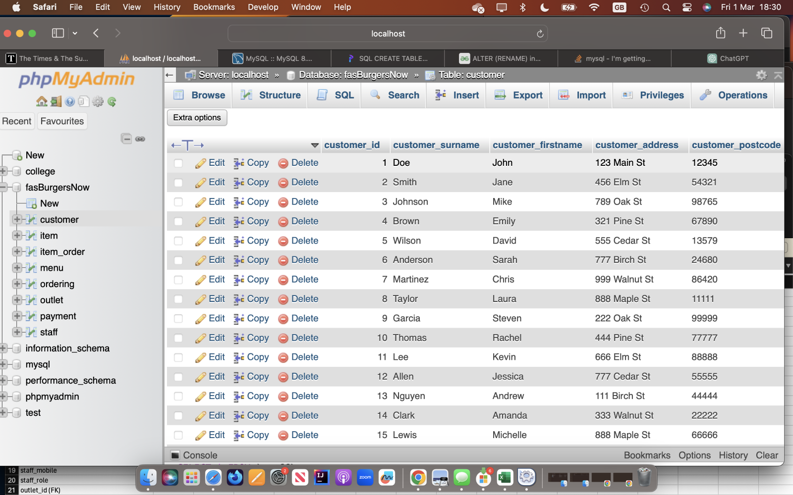

Select *

From staff

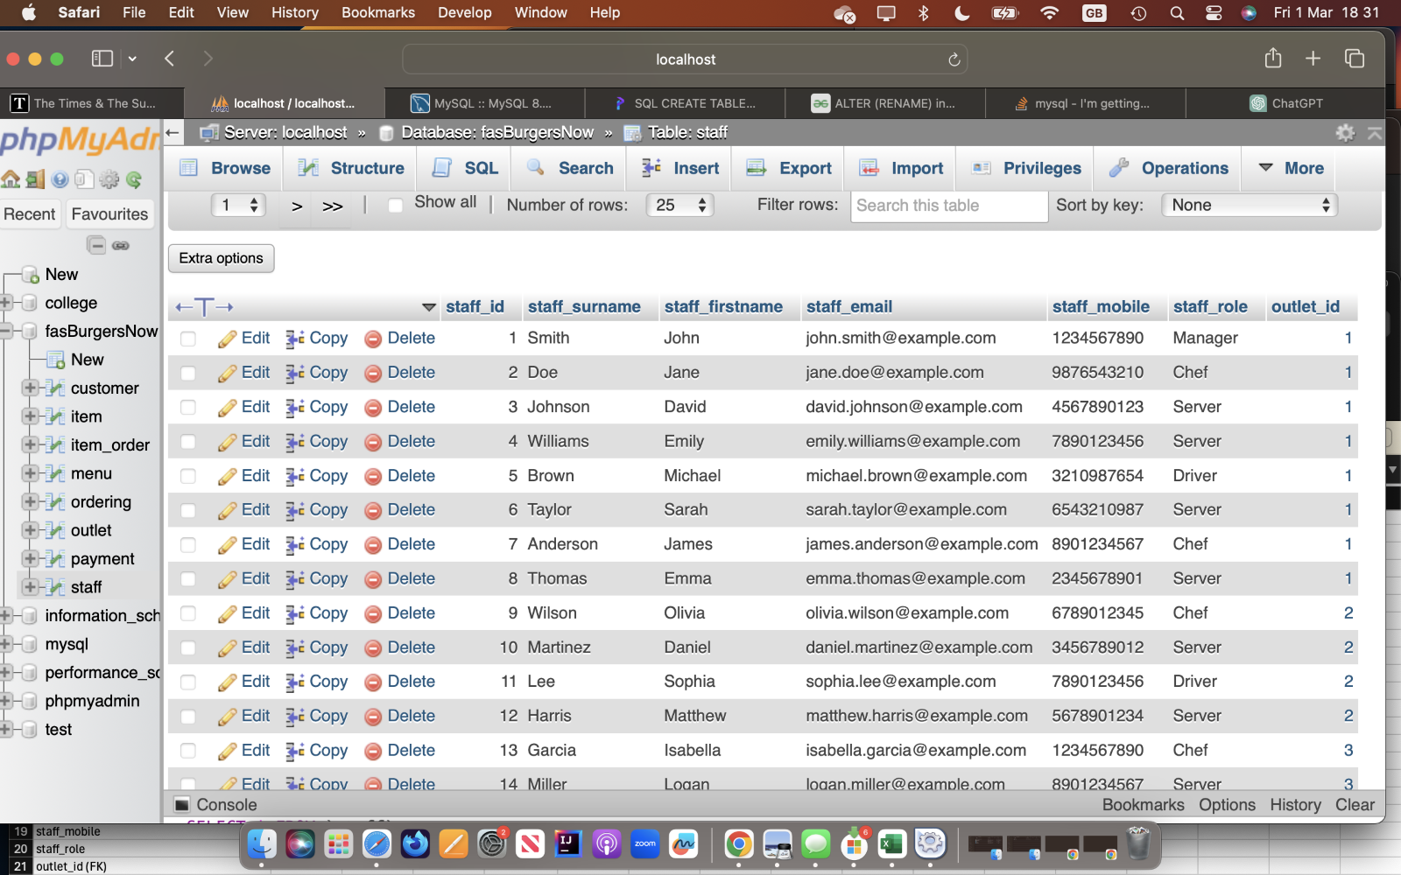

Q2. Show the output from two of the adjacent tables in turn – that is order and customer;  staff and order.

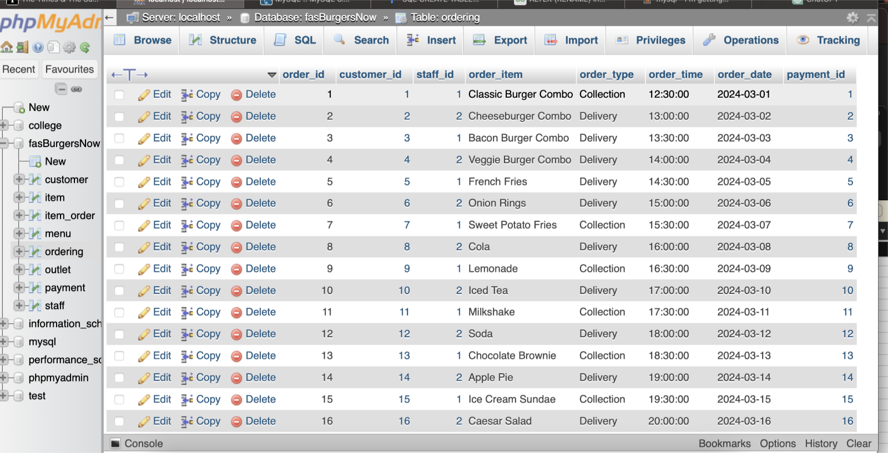

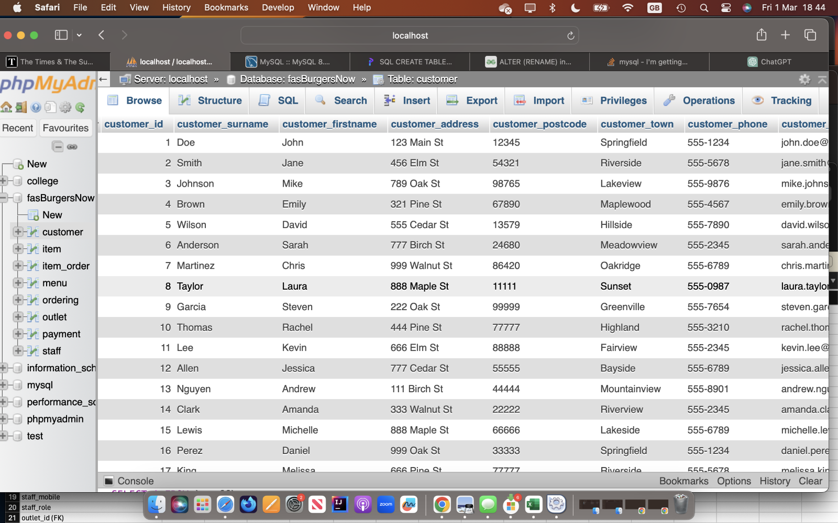

Staff

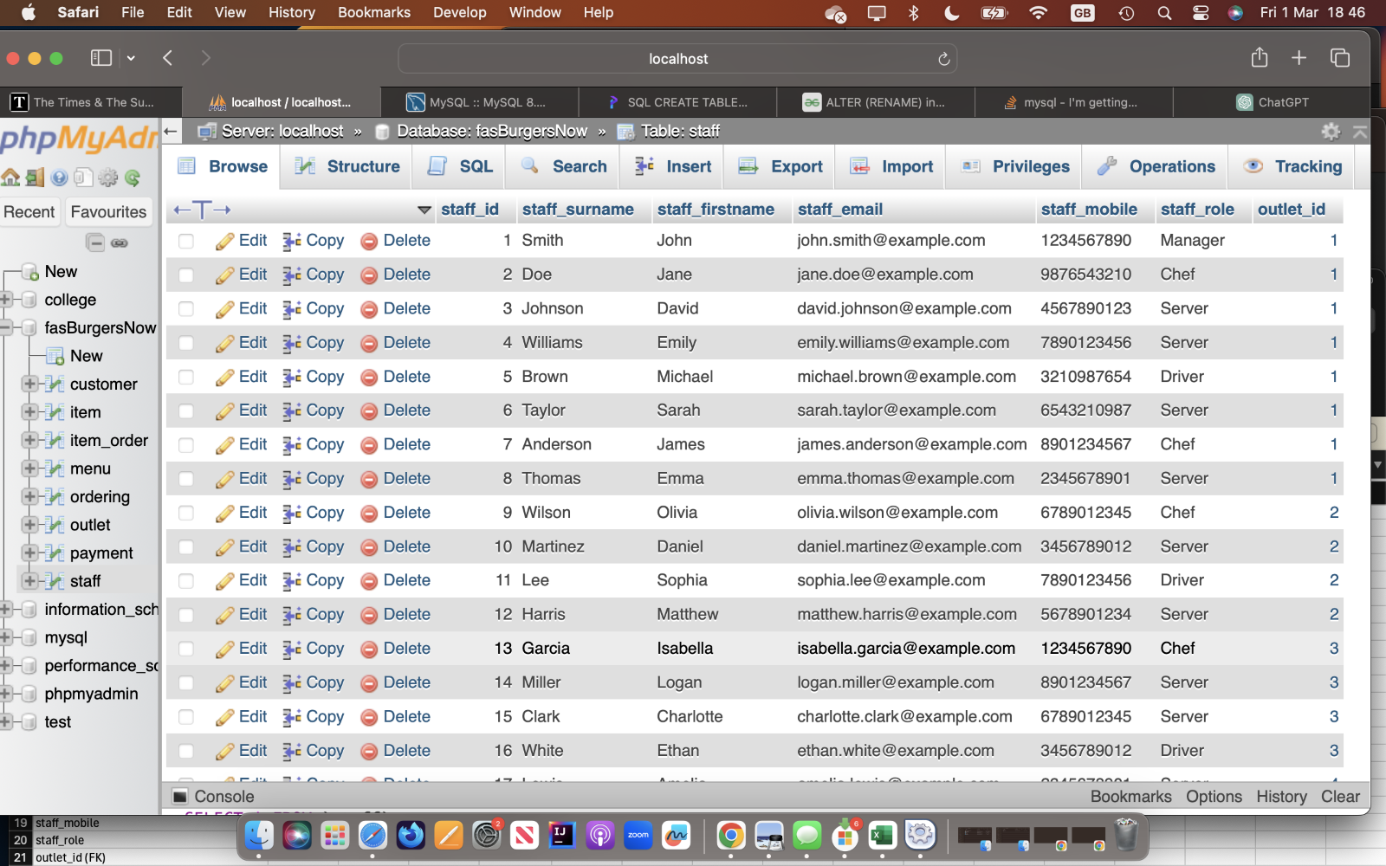

Order

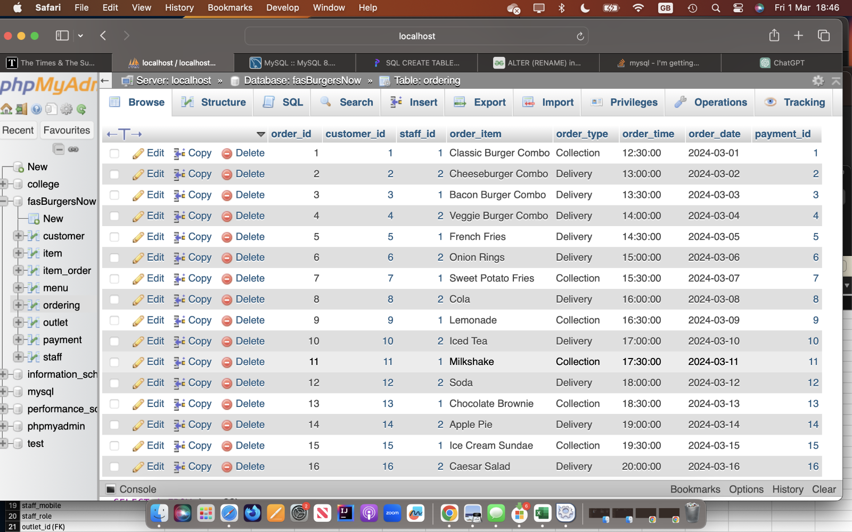

Q3. Connect all three tables and display the output that shows the output from these three tables – customer, order and staff.

SELECT *

FROM customer

JOIN ordering

ON customer.customer_id = ordering.customer_id

JOIN staff

ON staff.staff_id = ordering.staff_id;

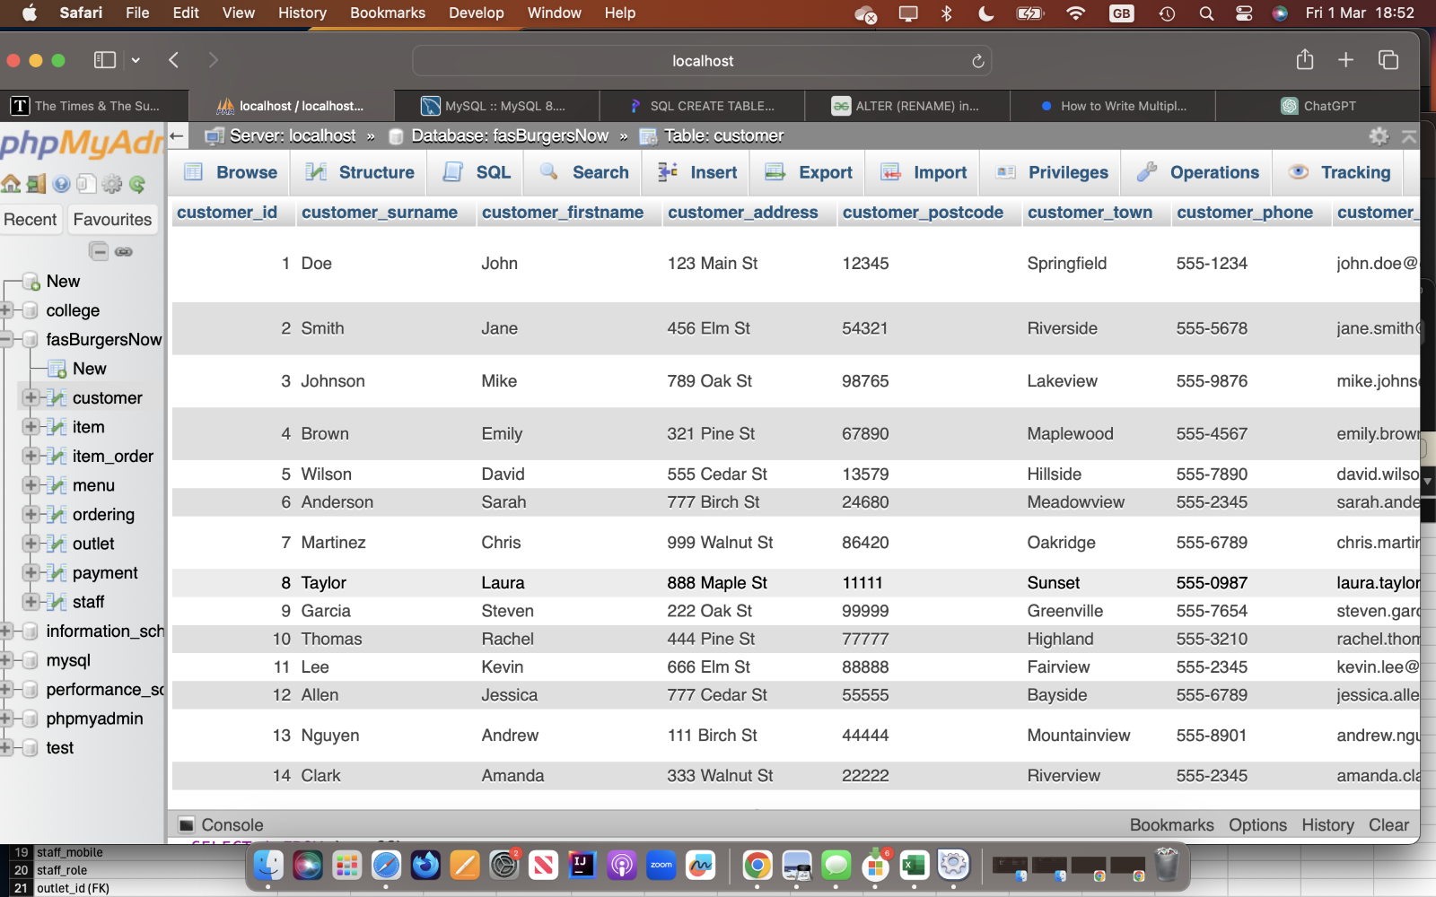

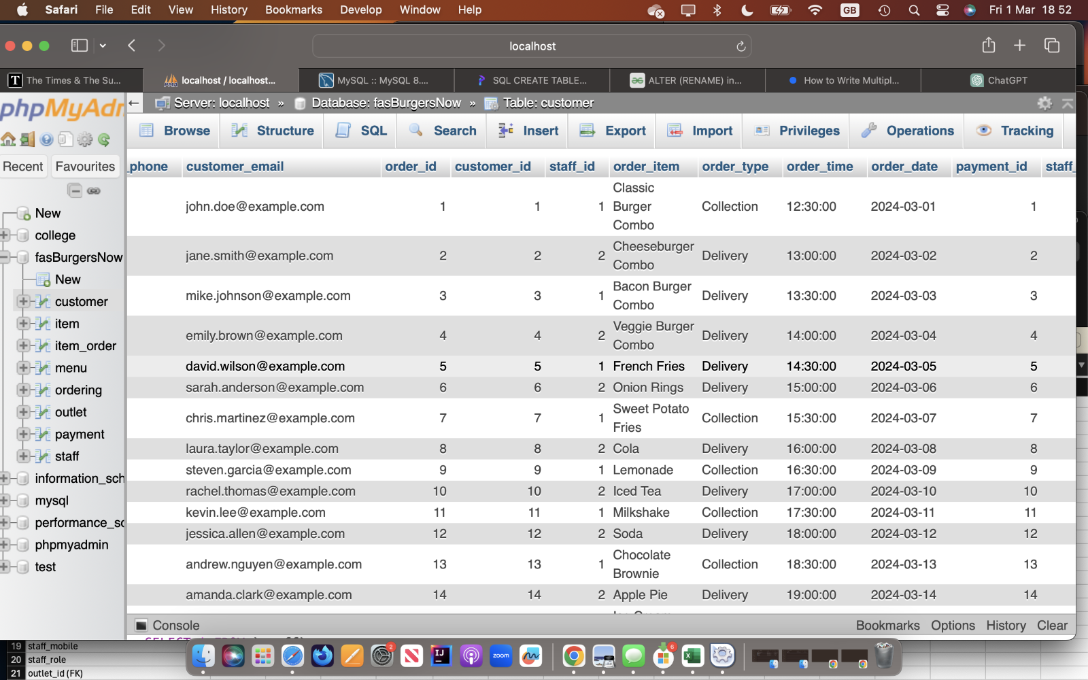

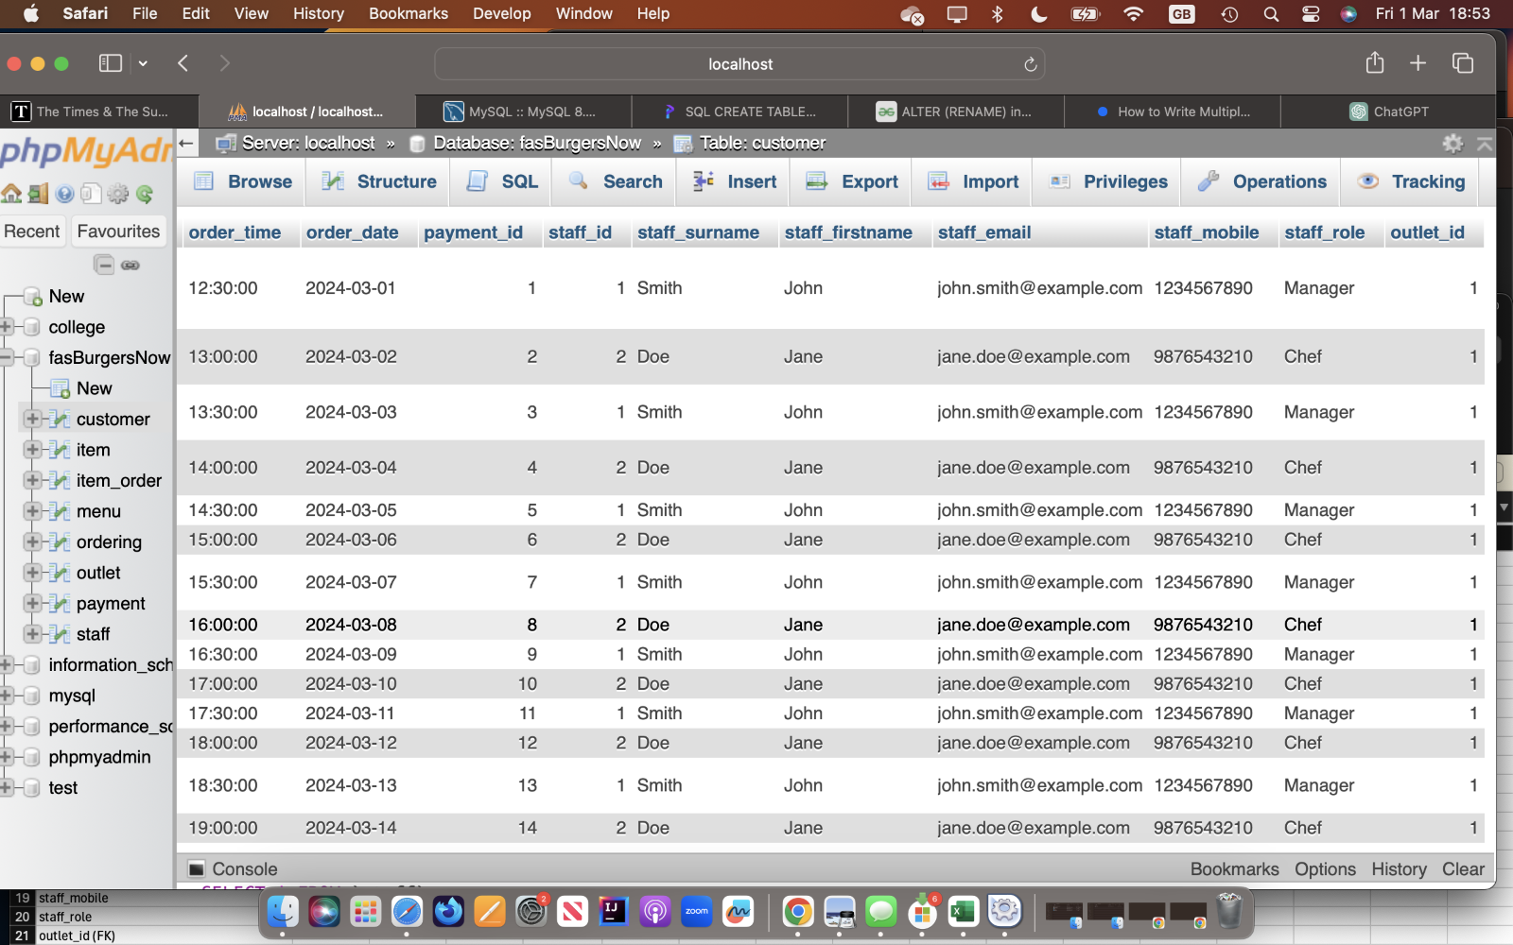

Q4. Create a query that will show the customer and payment – so link these two tables and produce the output.

SELECT *

FROM customer

JOIN payment

ON customer.customer_id = payment.customer_id

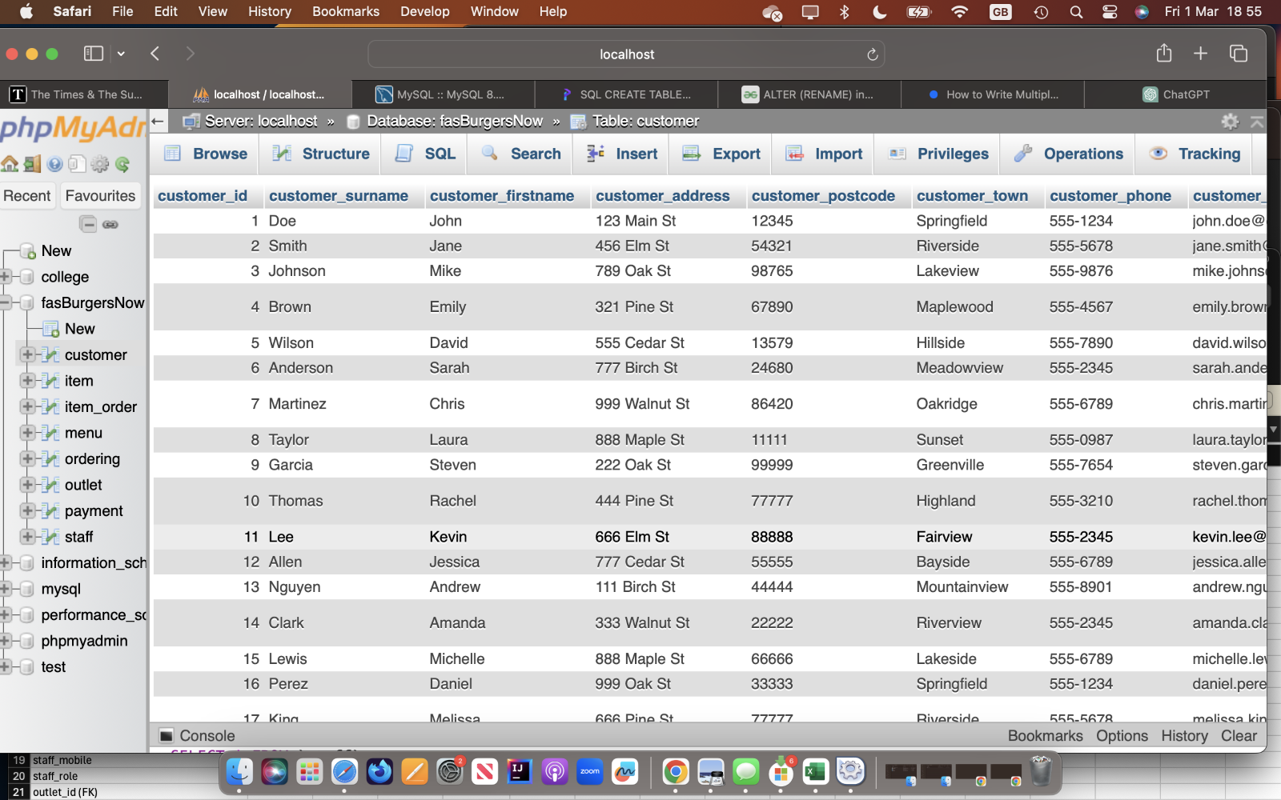

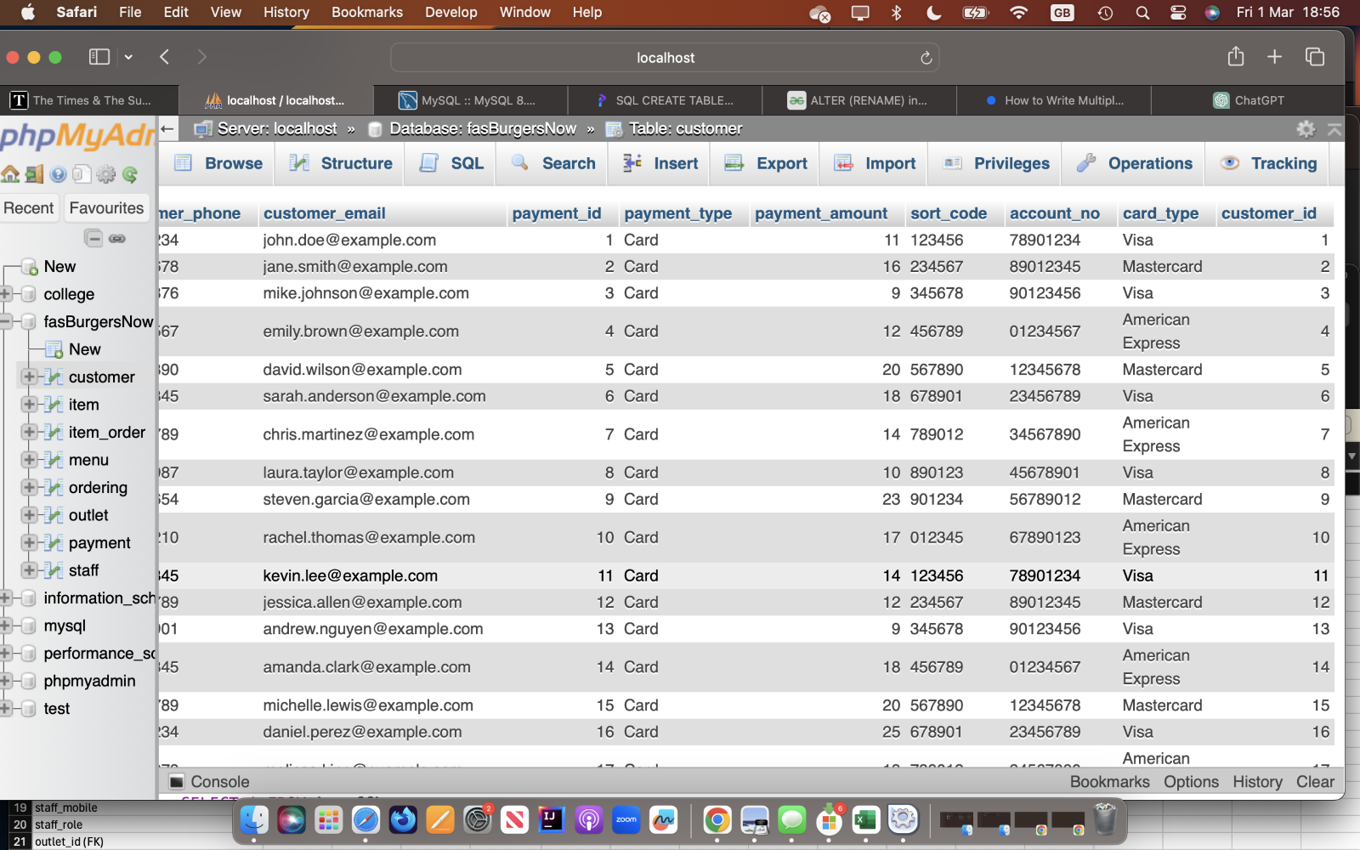

Q5. A manager wants to show a catalogue of the items in the system and their quantities.

